Introduction to NodeJS
Why Use NodeJS
- Node.js is a lightweight and fast runtime based on the V8 JavaScript engine. It is based on a single-thread architecture and event-driven model, which means that it doesn’t need to create a new thread for each request.

- Node.js is cross-platform, which means that we can run it on any operating system and architecture available in the modern market. It is multipurpose. While it is mostly used to build web applications; however, it can be used to build any kind of application.

- It’s easy to learn since it is based on JavaScript. Also, the NodeJS API is designed such that it can be learnt progressively, without understanding all the concepts at once.

- It has a large package ecosystem. There are more than 2.5 million packages available in the NPM (Node Package Manager) repository.

- It has a large community of developers who constantly contribute to maintain and improve the NodeJS Project. The Node.js Foundation merged with the JS Foundation in 2019 to create the OpenJS Foundation (https://openjsf.org/), which is the current organization that governs the Node.js project and other key projects in the JavaScript ecosystem, such as Appium, jQuery, Electron, Express, and webpack.

The NodeJS Single Thread Architecture
- NodeJS was created in 2009 by Ryan Dahl. NodeJS technology aimed to achieve 2 things: server-side JavaScript and non-blocking I/O.

- The I/O approach commonly used by other web application frameworks is to create a new thread for each request, an expensive operation since it increases RAM consumption and lowers performance. The rationale for this approach is to split the system resources and assign them to each thread. However, this approach is extremely inefficient since CPUs are idle most of the time, waiting for resources and increased RAM consumption, since each thread needs its own memory.

- NodeJS moves away from the above approach and uses a single thread Non-blocking I/O to free the resources while waiting so that it can continue processing requests. This is made possible using 2 libraries: libuv and V8.

The NodeJS Architecture
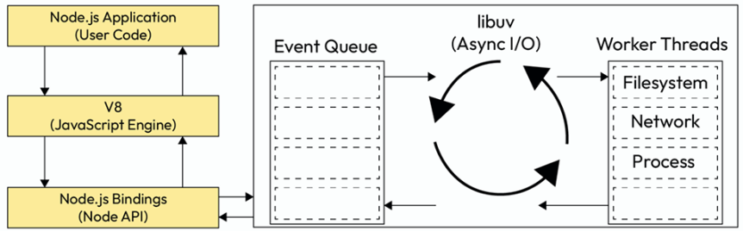
It has the following components:
- NodeJS Application: This is the NodeJS program that we write.
- V8: This is the engine encapsulated in Node.js that will execute our JavaScript code. V8 is the same engine that is used in the Chrome and Edge browsers under the hood.
- NodeJS Bindings: The Node.js bindings are the C/C++ code that will be executed under the hood when we use the Node.js APIs. This is why NodeJS is so fast.
- libuv: This is the C library that will handle the I/O operations with multi-platform support. It will use the thread pool to execute the blocking operations and it will notify the Node.js bindings when the operation is completed.
NodeJS Versioning
NodeJS uses Semantic Versioning. This kind of versioning has the following syntax:
<major_version>.<minor_version>.<patch_version>-<pre_release_version>+<build>
This is explained below:
- Major versions add incompatible API changes.
- Minor versions add functionality in a backward-compatible manner.
- Patch versions add backward-compatible bug fixes.
NodeJS Releases
Release Details
Every release has a structured blog post with the following information:
- Summary: Here, we can find a brief description of the release.
- Notable Changes: Here, we can find the most important changes in the release, including examples. We can also see the more relevant changes in the dependencies that may affect the Node.js APIs.
- Semver-(*) Commits: Here, we can find the commits that are related to the SemVer changes.

Release Schedule
- Current is the phase where new features (non-major changes) are added to the project. This phase is very active. This type of release isn’t recommended for production use as it isn’t stable.

- Active Long-Term Support (LTS) is the phase where the version is stable and has been updated by the LTS team. This phase still includes new features, bug fixes, and updates. It is stable and can be used for production.

- Maintenance is the phase where the version is not receiving any new features, only critical bug f fixes and security updates. This phase is recommended for projects that are not able to upgrade yet to the latest active LTS version.

Note: Odd numbered releases aren’t promoted to Active LTS, so thay can’t be used for production.

